How To Change the Application Language in Apex.

In order to change the application language from default English to Arabic, Dutch and etc, we need to use Globalization and Translation option in shared component of an application.

In Translation we create a shadow copy of an existing application in other language.

And in Globalization we just set the other language as primary language.

Steps in Translation

Go to shared component🡪 Translate Application

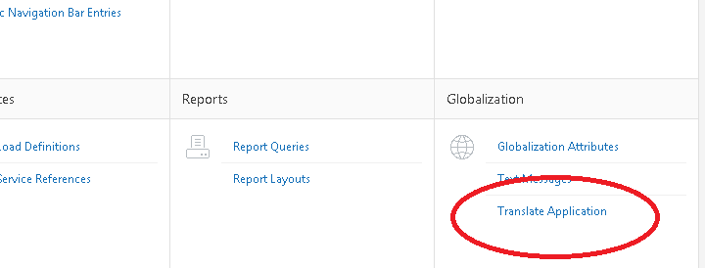

Go to “define application languages”

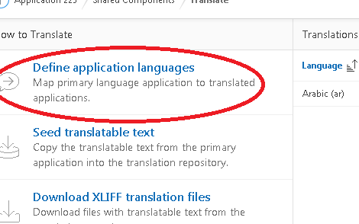  
Click on “Create” button-🡪 give proper id (no zeros on upper and lower bound) and select the desired language. And then apply create button.

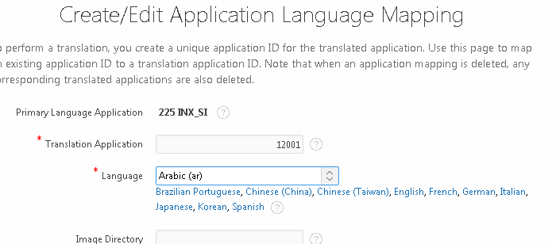

Click on translate again.

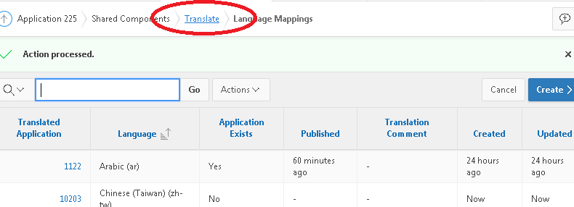

Go to “Seed Translatable Text” (2nd option).

Check the language you want to seed, then apply seed button.

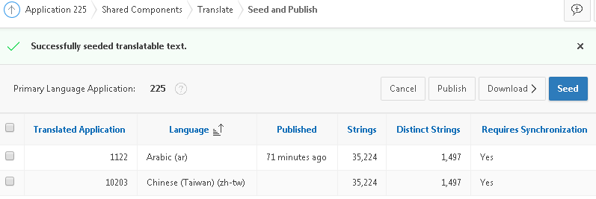

**Note:**when you change something afterwards in your primary application you have to seed again.

Click on translate again on top.

And Select “Download XLIFF translation file”.

Select your language only in the first top and apply Export file for App.

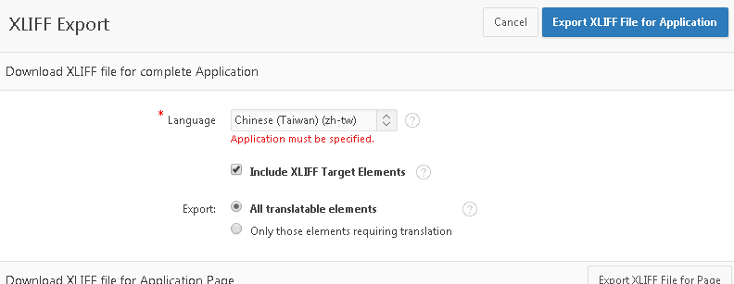

Open the XLIFF file that was downloaded using a text editing tool (Notepad++) and translate the elements by replacing the target with an equivalent translated phrase. Like this

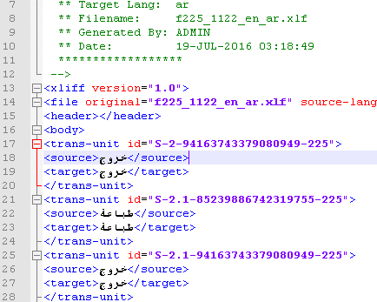

After Making Changes save this translated XLIFF file (xml based file).

Again go to translate and select “Apply XLIFF Translation Files”

Click “Upload File” button🡪 Choose your translated file in XLIFF format-🡪 Apply “Upload”.

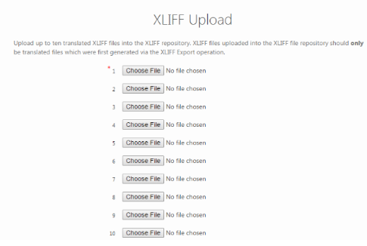

Check Mark your shadow app and select the original app and apply button “Apply Checked”

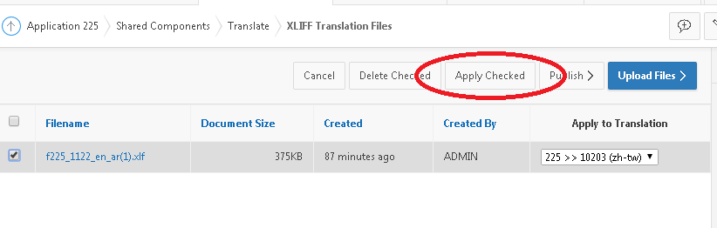

Again go to translate and select “Publish Translated Application”

Check Mark your translated shadow app and apply button “Publish”

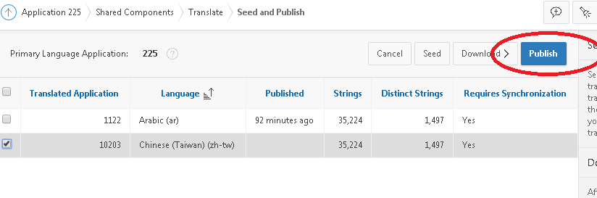

**Now, Go to Globalization, set your desired language as primary language and Apply Change.**

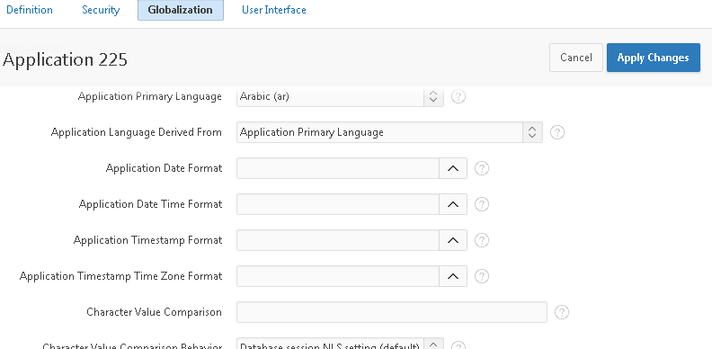

**Finish.**